

Chittagong University of Engineering &

Technology

Chattogram - 4349

Software Engineering (Sessional)

CSE-434

Report On

**Design Model using Component Diagram**

# Name of the Students:

|  |  |  |
| --- | --- | --- |
| Nizia Nahyan | Muhsina Khan | Kaniz Fatima |
| *ID: 1504043* | *ID: 1504032* | *ID: 1504045* |

**Structure of our Doctor Recommending System :**

A **recommender system**, or a **recommendation system** (sometimes replacing 'system' with a synonym such as platform or engine), is a subclass of [information filtering system](https://en.wikipedia.org/wiki/Information_filtering_system" \o "Information filtering system) that seeks to predict the "rating" or "preference" a user would give to an item.They are primarily used in commercial applications.[1]

Our goal is to make a recommender system that takes input symptoms from patients and recommends us suitable doctor according to doctors’ information.

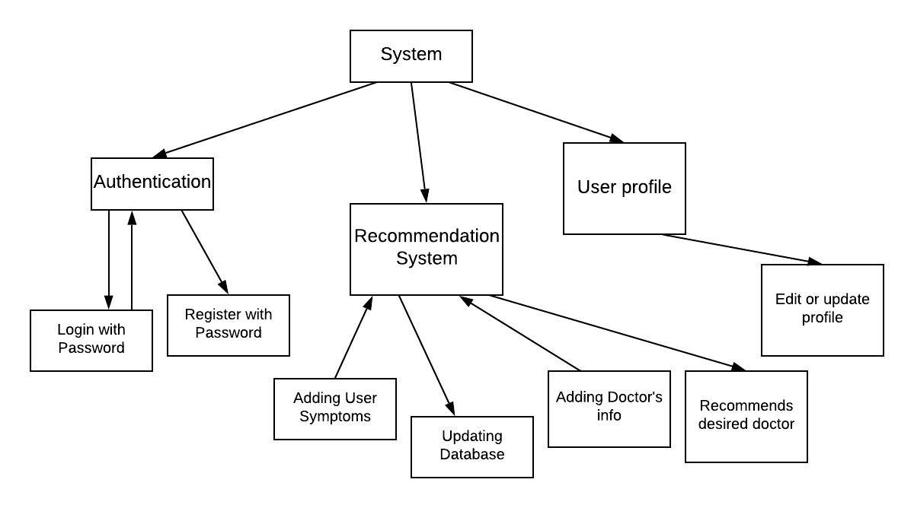

Figure 1 : Structure of our System

**Component Level design of our System :**

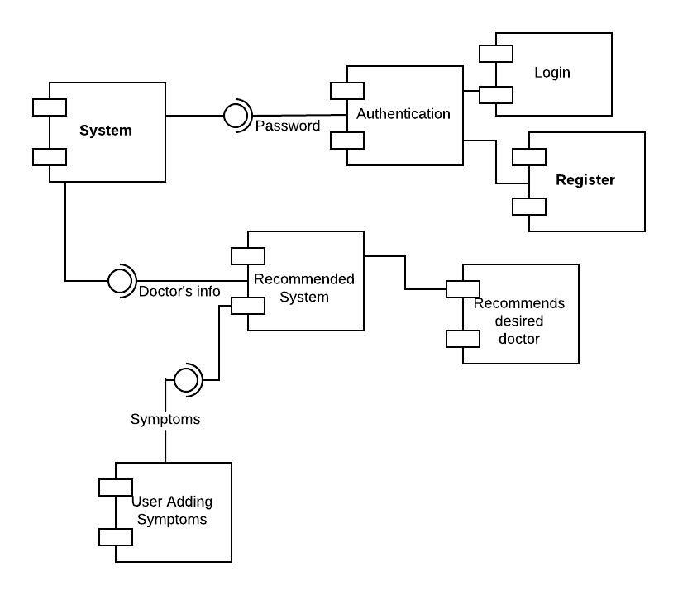

Figure 2 : Component level design of our system

**Object Oriented View :**

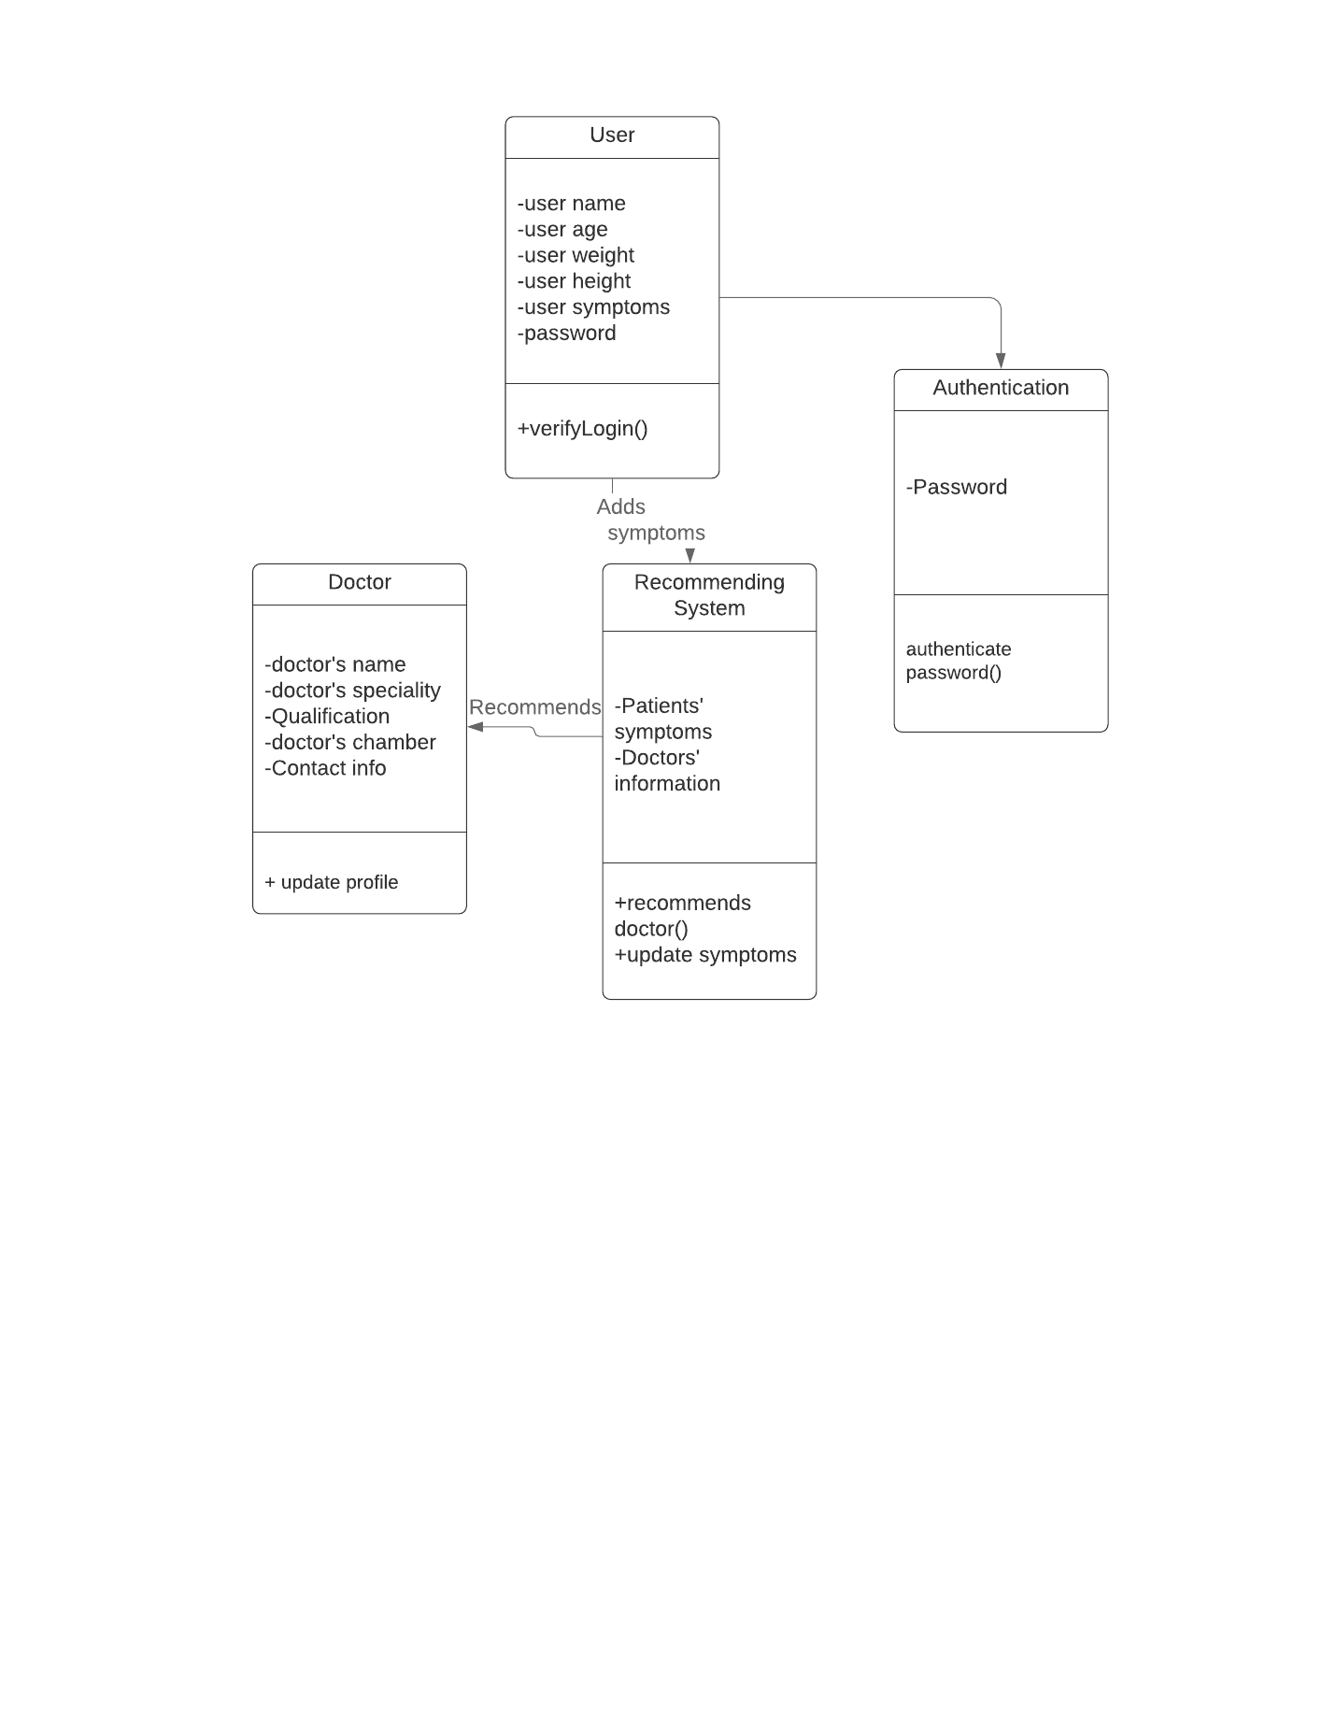

Figure 3 : Class diagram of our system

**Reference :**

1. <https://en.wikipedia.org/wiki/Recommender_system>
2. Y. Cai, Y. Su, L. Zhao and Z. Cui, "Algorithm Design of Push Service for Telemedicine System," 2018 International Conference on Robots & Intelligent System (ICRIS), Changsha, 2018, pp. 250-252.
3. L. Guo, B. Jin, R. Yu, C. Yao, C. Sun and D. Huang, "Multi-label classification methods for green computing and application for mobile medical recommendations," in IEEE Access, vol. 4, pp. 3201-3209, 2016.
4. A. John, M. I. H. and V. Vasudevan, "Medication recommendation system based on clinical documents," 2016 International Conference on Information Science (ICIS), Kochi, 2016, pp. 180-184.
5. H. J. Lee and H. S. Kim, "eHealth Recommendation Service System Using Ontology and Case-Based Reasoning," 2015 IEEE International Conference on Smart City/SocialCom/SustainCom (SmartCity), Chengdu, 2015, pp. 1108-1113.
6. S. Swarnalatha, I. Kesavarthini, S. Poornima and N. Sripriya, "Med-Recommender System for Predictive Analysis of Hospitals and Doctors," 2019 International Conference on Computational Intelligence in Data Science (ICCIDS), Chennai, India, 2019, pp. 1-5.

[7] Yong-Feng Huang, Peng Liu, Qiao Pan and Jing-Sheng Lin, "A doctor recommendation algorithm based on doctor performances and patient preferences," 2012 International Conference on Wavelet Active Media Technology and Information Processing (ICWAMTIP), Chengdu, 2012, pp. 92-95.